Answer 5
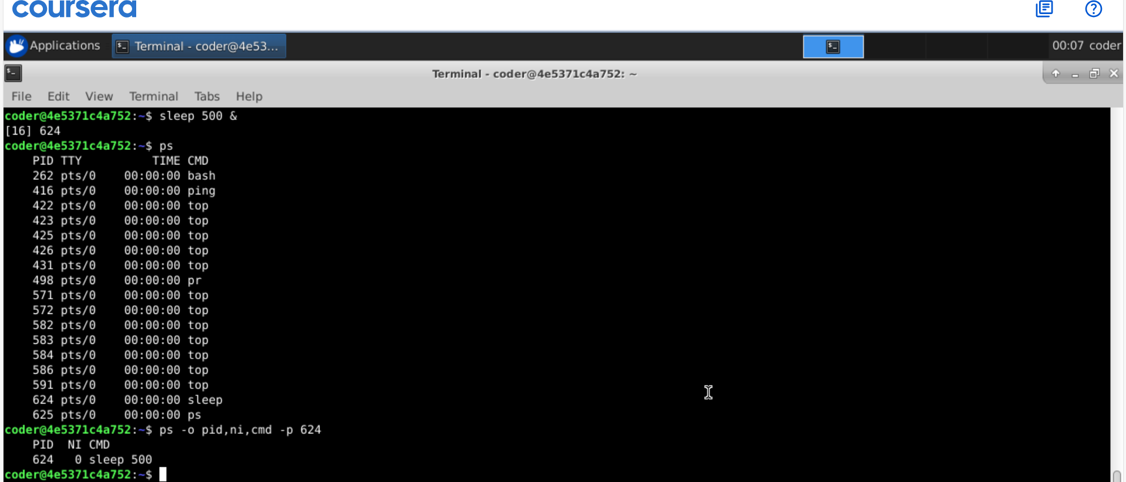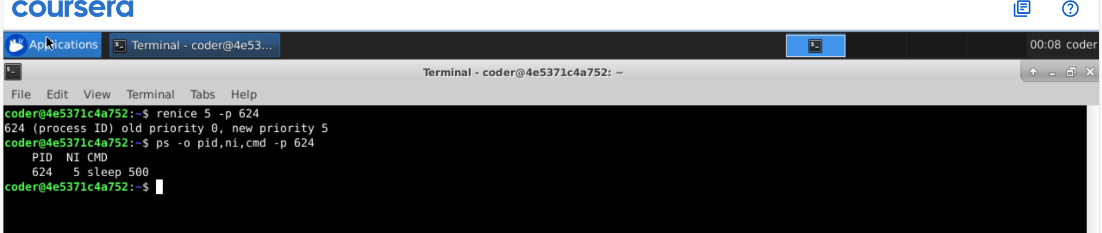
Explanation: using ps command followed by priority number followed by option -p followed by the PID will change the priority of the process. We can check using ps -o for desired format for the output followed by option p and PID.

